**Si te ndryshojme te drejtat (permissions) ne Linux**

Per te ndryshuar directory permissions ne Linux perdoerim:

* **chmod +rwx filename**  per te shtuar permissions.
* **chmod -rwx directoryname** per te hequr permissions.
* **chmod +x filename** per te lejuar executable permissions.
* **chmod -wx filename** per te hequr write and executable permissions.

**Shenim:**

“r” eshte per read (lexo), “w” eshte per write(shkruaj), and “x” eshte per execute(ekzekuto).

Kjo ndryshon te drejtat (permissions) per zoteruesin e fajllave

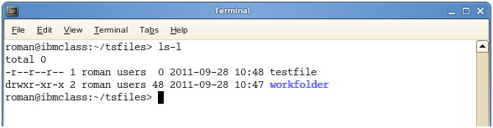

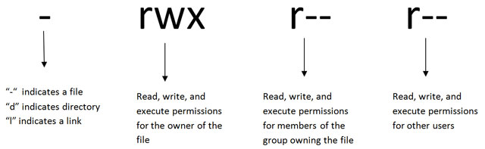

“-” tregon nje fajll

“d” tregon direktori

“l” tregon nje link

rwx (read , write, ecxecute)

r-- (read ,write, ecxecute per anetaret e grupit qe zoteron fajllat)

r-- (read ,write, ecxecute per perdoruesit e tjere)

**Si te ndryshojme Directory Permissions ne Linux per Zoteruesit e Grupit, (Group Owners)**

Komanda per te ndryshuar directory permissions per group owners eshte e ngjashme, por shtojme nje “g” per group ose “o” per users:

* **chmod g+w filename(emertimi i fajllit)**
* **chmod g-wx filename (emertimi i fajllit)**
* **chmod o+w filename (emertimi i fajllit)**
* **chmod o-rwx foldername (emertimi i folderit)**

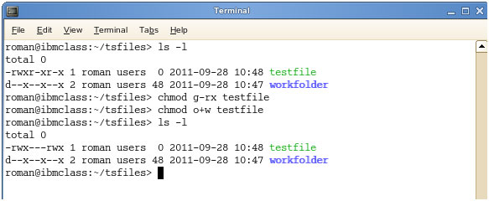

Per te ndryshuar directory permissions per te gjithe ( everyone), perdorim “u” per users, “g” per group, “o” per others, dhe “ugo”ose “a” (per te gjithe).

* **chmod ugo+rwx foldername** to give read, write, and execute to everyone.
* **chmod a=r foldername** to give only read permission for everyone.
* **chmod ugo+rwx foldername** per te dhene read, write, dhe execute tek te gjithe( everyone).
* **chmod a=r foldername** per te dhene vetem read permission per te gjithe (everyone).

**Si te ndryshojme grupet e fajllave dhe direktorive ne Linux**

* **chgrp groupname filename**
* **chgrp groupname foldername**

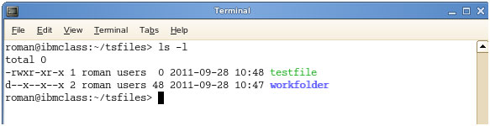

**Si te ndryshojme pronesine e fajllave (Ownership ne Linux)**

* **chown name filename**
* **chown name foldername**

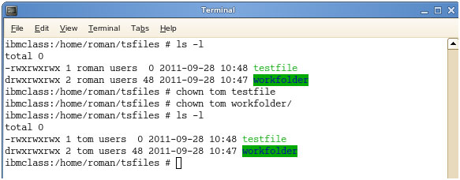

These commands will give ownership to someone, but all sub files and directories still belong to the original owner.

Keto komanda I japin ownwrship dikujt, port e gjithe nenfajllat dhe direktorite I perkasin akoma zoteruesit (owner) fillestar